  - Random Weather Generator

  - Document History
Date | Version | Role | Name | Comment
9/9/2025 | 1.0 | Business Analyst |  | Created initial draft
Contents
I. Introduction 3
1.1. Purpose 3
1.2. Objectives 3
1.3. Process key contacts 3
1.4. Minimum prerequisites for the automation 4
II. As-is process description 4
2.1. Process overview 4
2.2. Applications used 5
2.3. As-is process map 5
2.3.1. High-level process map 5
2.3.2. Detailed level process map 6
2.4. Detailed as-is process actions 6
III. To-be process description 6
3.1. Detailed to-be process map 6
3.2. Input/Output data description 6
3.3. Exceptions Handling 7
3.4.1. Known business exceptions 7
3.4.2. Unknown business exceptions 7
3.4. Applications errors and exceptions handling 7
3.5.1. Known applications errors and exceptions 7
3.5.2. Unknown applications errors and exceptions 8
3.5. Reporting 8
3.6. In scope for automation 8
3.7. Out of scope for automation 8
3.8. Change/Improvement details 9
IV. Other 9
4.1. Additional sources of process documentation 9
4.2. Change requests 9
4.3. Document approval 10

Introduction

Purpose
The purpose of designing this process as a state diagram is to provide a high-level representation of how the system transitions through different operational states when generating and storing random weather data.

Objectives
The objective of the current weather generation process is to ensure that users can seamlessly create random weather outputs based on selected parameters. The process aims to provide accurate weather data by allowing users to configure key inputs such as climate, season, and supernatural conditions, then generate and store the results efficiently .
Objectives | Benefits
Improve overall reliability and performance | Consistent generation of weather outputs without manual errors
Reduce human error | Eliminates mistakes in configuring inputs or saving outputs
Speed up weather generation cycle | Faster retrieval and output compared to manual selection and recording
Ensure accuracy and consistency in data | Automated handling of inputs and outputs maintains standardized results
Enhance compliance with defined rules | Ensures only valid parameters (e.g., climate, season, conditions) are applied
Increase scalability | Ability to process multiple generation requests without extra effort
Reduce operational effort | Lowers dependency on repeated manual actions like input entry and saving results
Improve exception handling and monitoring | Automated error logging and consistent handling of invalid inputs or system errors

Process key contacts
The specifications document includes concise and complete requirements of the business process, and it is built based on the inputs provided by the process Subject Matter Expert (SME)/ Process Owner.
The Process Owner is expected to review it and provide signoff for accuracy and completion of the steps, context, impact, and complete set of process exceptions.
The names have to be included in the table below.

Role | Name | Contact Details
Business Analyst | Youssef Kamel | Youssefmk1214@gmail.com
Process SME / Process reviewer | Mohamed Mesbah | Mohamed.mesbah@rackist.com

Minimum prerequisites for the automation
- Filled-in Process Definition Document
- Test Data to support development.
- User access and user accounts creations (Access to the weather generator web application, including any licenses, permissions, and restrictions for robots. Credentials (user ID and password) required to log )
- Storage Location (Defined local or network folder path where generated weather data files (e.g., text outputs) will be stored).

Business Rules
BR# | Requirement | Additional Information
BR001 | When selecting climate, ensure only valid options (e.g., Warm, Cold, Temperate) are allowed | Invalid inputs should trigger an error message and prevent further processing
BR002 | If “Supernatural condition” is selected as “Rare,” additional details must be captured | The system must record the condition in the generated output file
BR003 | Weather data must be generated only after all mandatory fields are filled | Mandatory fields include Climate, Season, and Supernatural Condition
BR004 | Generated weather data must be saved to a designated output folder | If saving fails, the system should log the error and notify support
BR005 | Each generated weather output must include both data values and description | Example: Temperature, Condition, and a text-based weather narrative

As-is process description

Process overview
The current As-Is process for generating random weather data is a semi-manual workflow carried out through an online weather generator tool. The process begins with accessing the generator via a web browser and navigating to the appropriate input fields. Users then configure the required parameters such as climate, season, and supernatural conditions before triggering the generation of results. Once the data is generated, the system provides weather details along with a descriptive narrative, which the user extracts and stores in a local text file for record-keeping .

Item | Description/Answer
Process Full Name | Weather Data Generation
Process Area | Environmental Simulation / Data Generation
Department | Research & Development / Analytics
Short Description (operation, activity, outcome) | The process opens the weather generator tool, configures parameters (climate, season, supernatural conditions), generates random weather data, and stores the results in a text file
Role(s) required in applications to perform the process | Analyst
Process schedule and frequency | On-demand
Number of items per month | 1,000 weather generation requests (average)
Average handling time per item | 3 minutes
Process Restrictions | Requires internet access and availability of the weather generator web application..
Peak Period (s) | NA
Peak Volume Approximate increase | NA
Total # of FTEs supporting this activity | 1 (currently handled manually by user)
Expected Volume increase during next periods | NA
Input data description | Warm State of climate , Winter Season of Season ,  Rare Condition of Supernatural Weather
Output Data description | Weather info data , Weather Description , txt file of data

Applications used
The table includes a comprehensive list of all the applications that are used as part of the process to be automated to perform the given actions in the flow.

Application Name | Details (Version, Language, Environment/ Access method)
Any Browser SW | Used To open Acme System 1

As-is process map

High-level process map
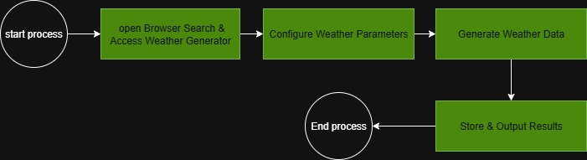

Detailed level process map
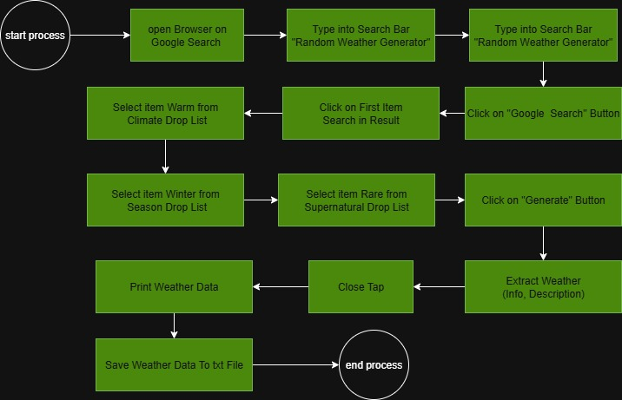

Detailed as-is process actions
# | Input | Description | Details | Exception Handling | Output
1 | - | Open Browser on Google Search |  | AE01 | 
2 | Credentials | Type Into Search bar “generate random weather” | 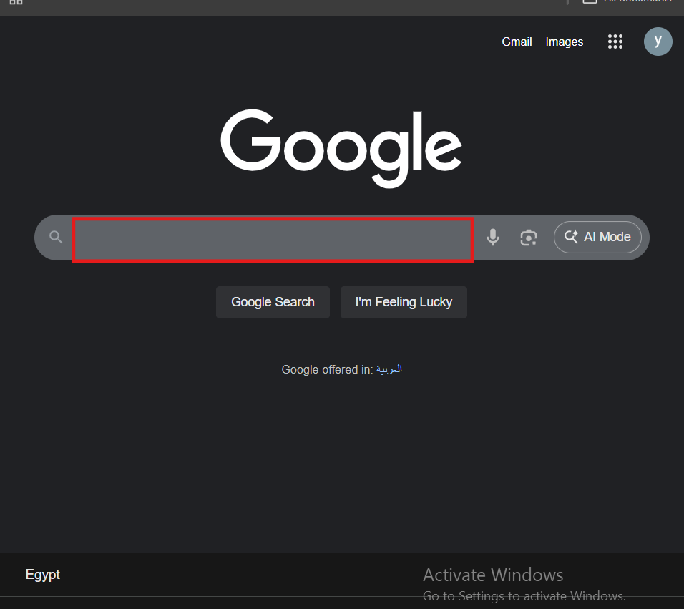 |  | 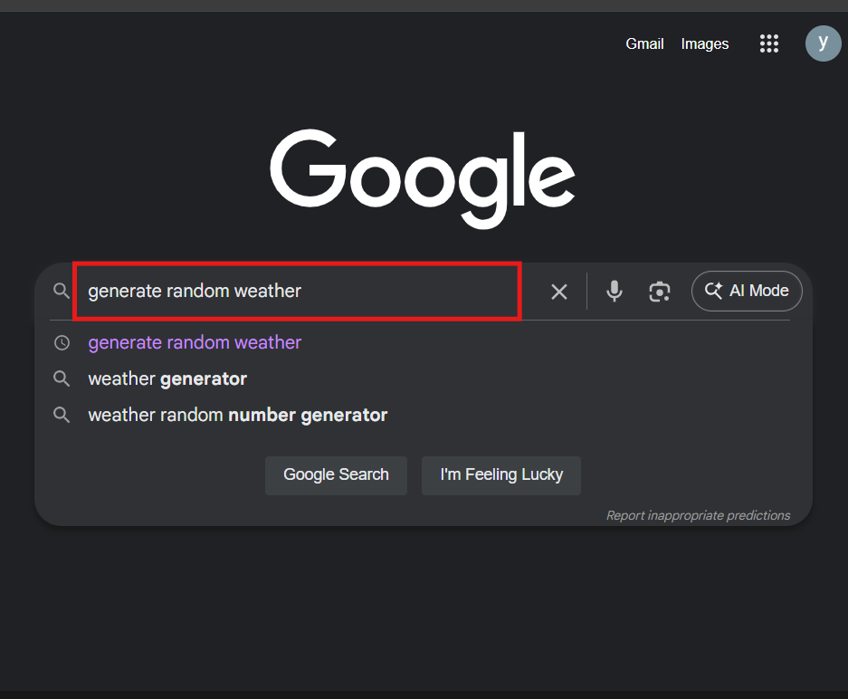
3 |  | Click on Google Search Button | 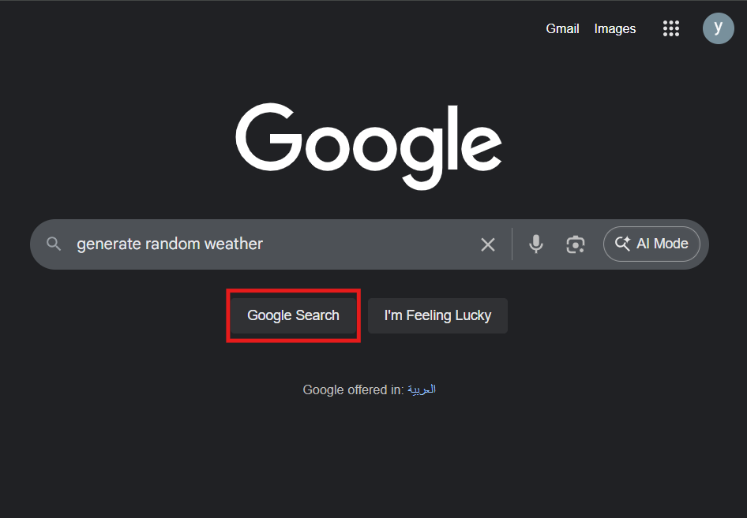 |  | 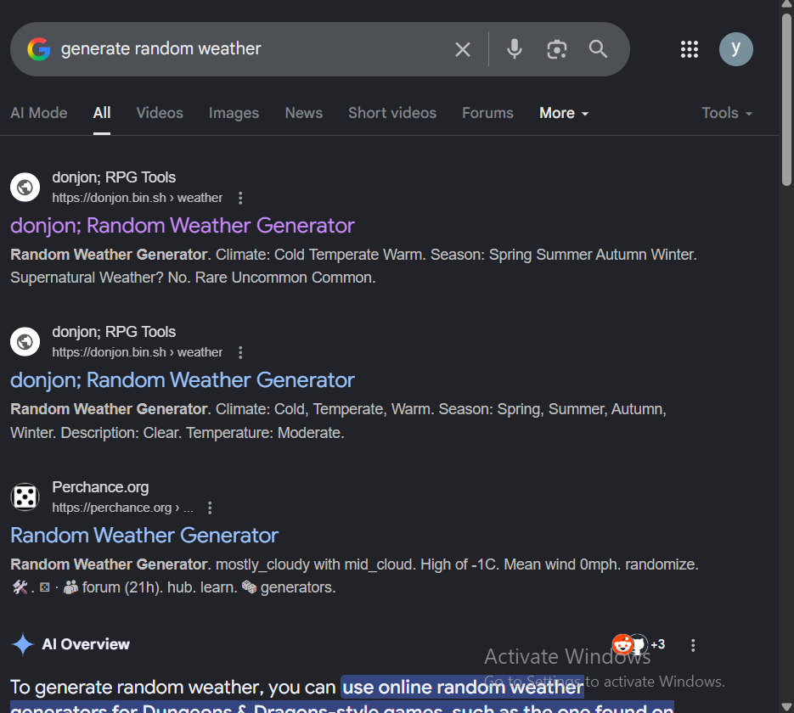
4 |  | Click on First Item on Search Result | 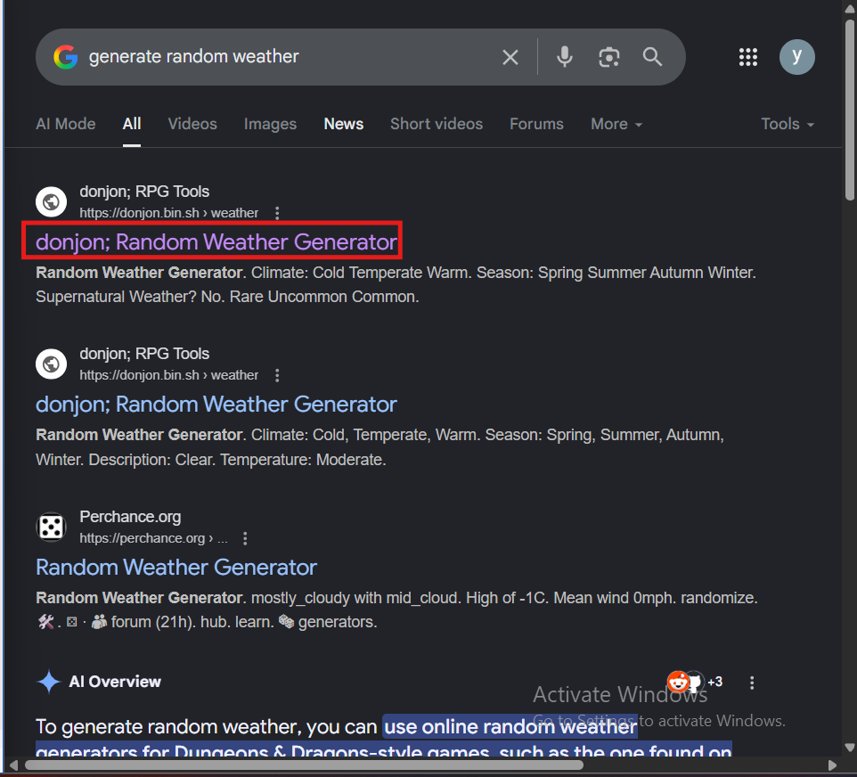 | BE03  or  AE02 | 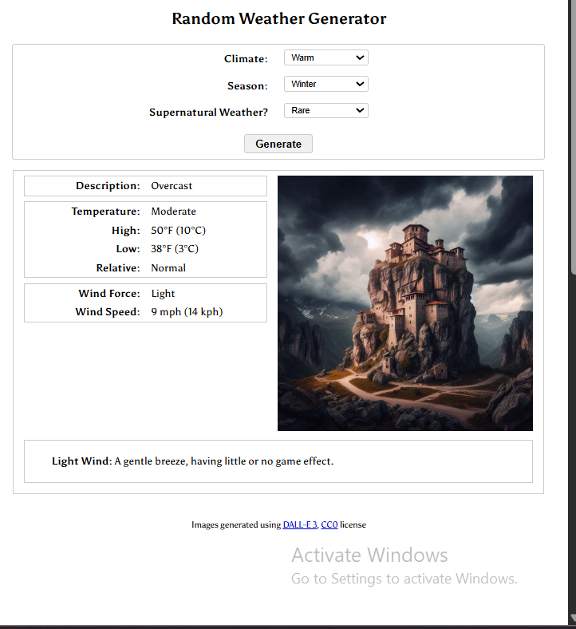
5 |  | Click on Climate Drop Down List and select Warm | 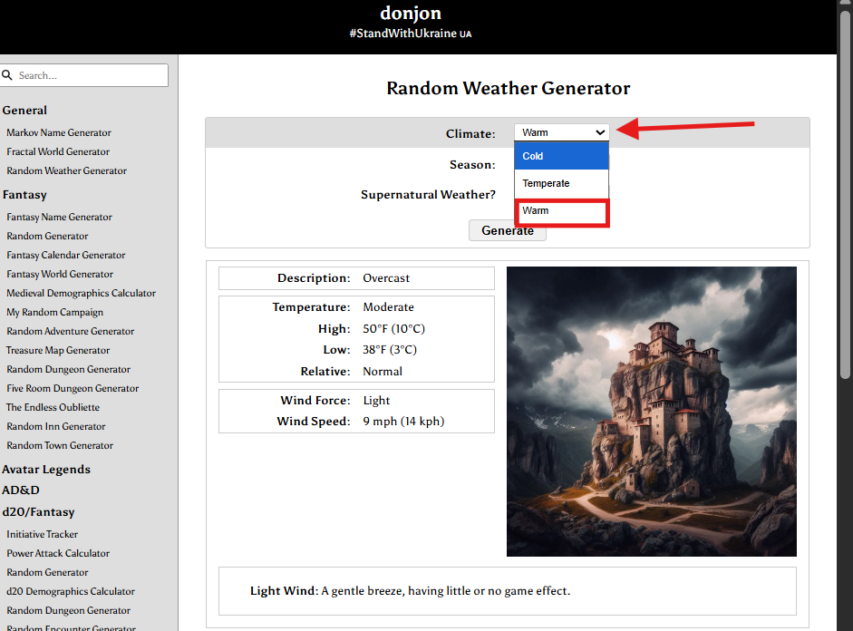 | BE02  or  AE03 | 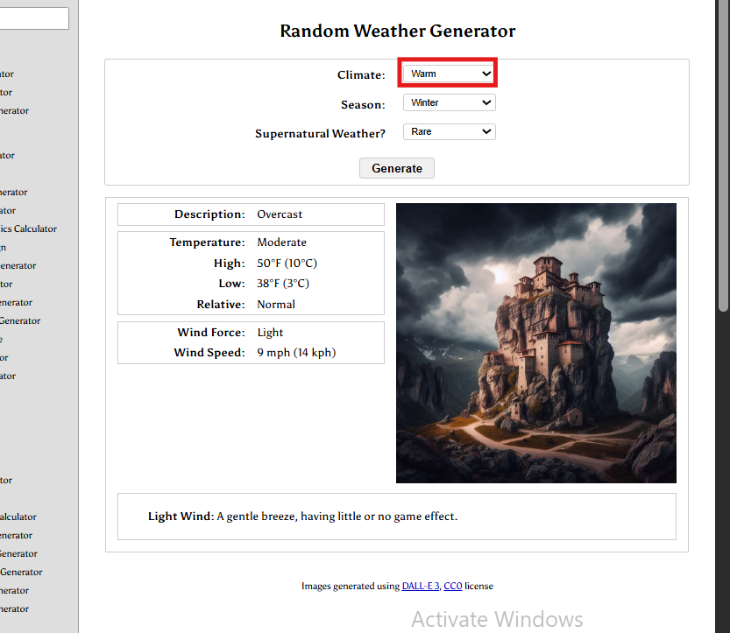
6 |  | Click on Season Drop Down List and select Winter | 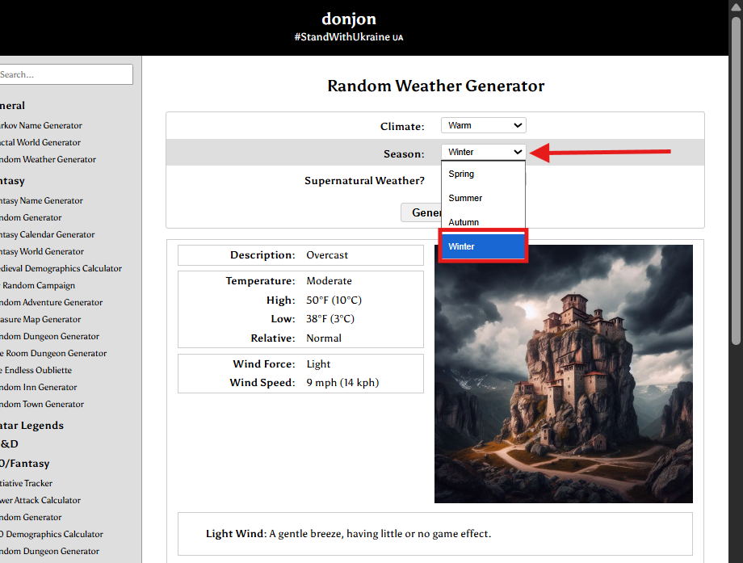 | BE02  or  AE03 | 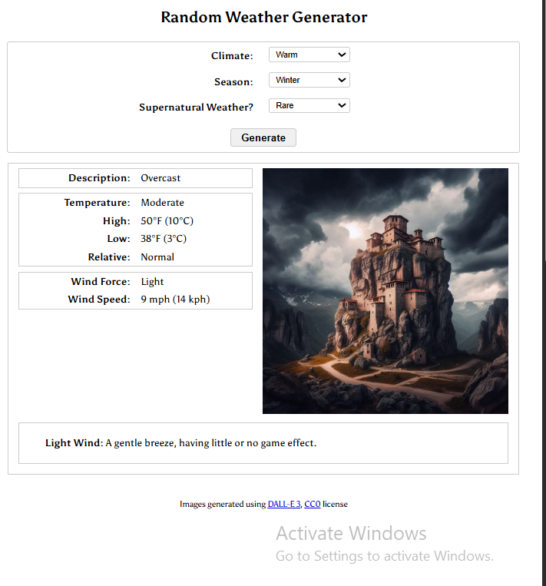
7 |  | Click on Supernatural Drop Down List and select Rare | 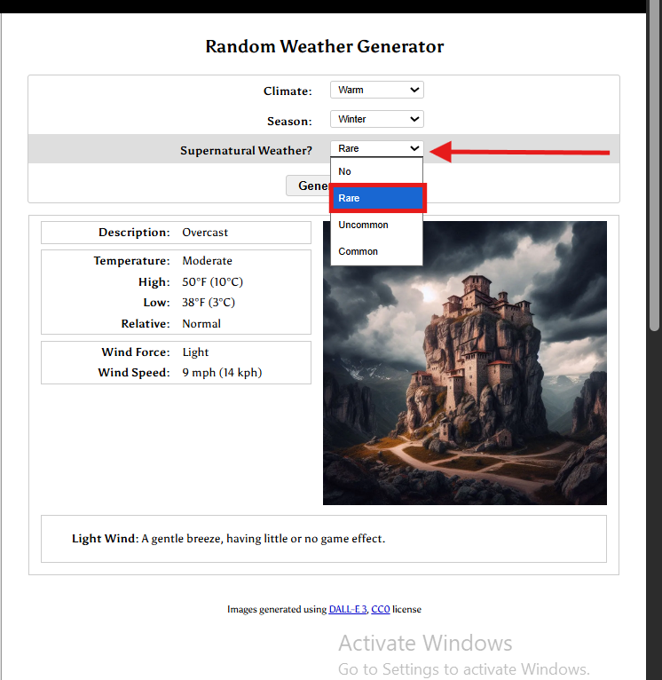 | BE02  or  AE03
8 |  | Click on Generate Button | 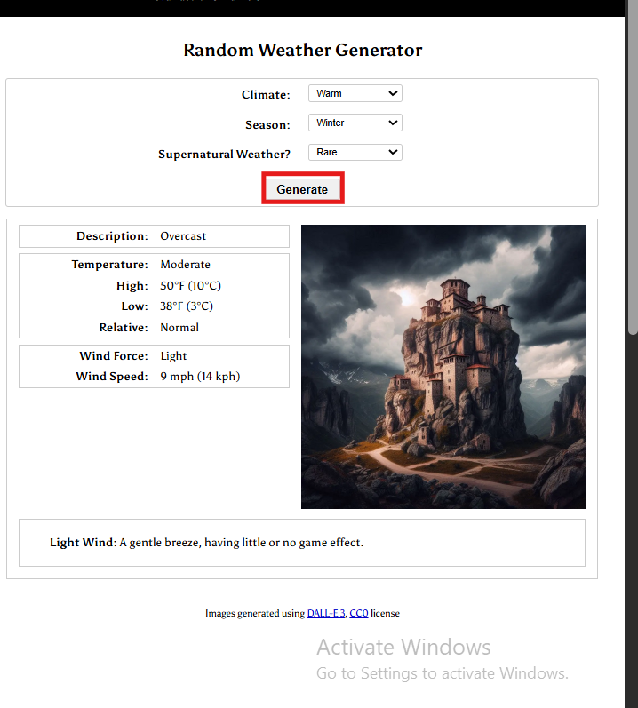 | AE04 | 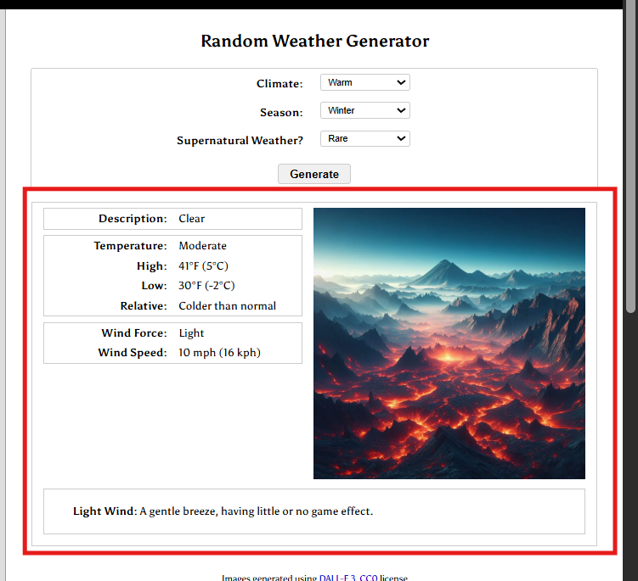
9 |  | Extract Weather info Text | 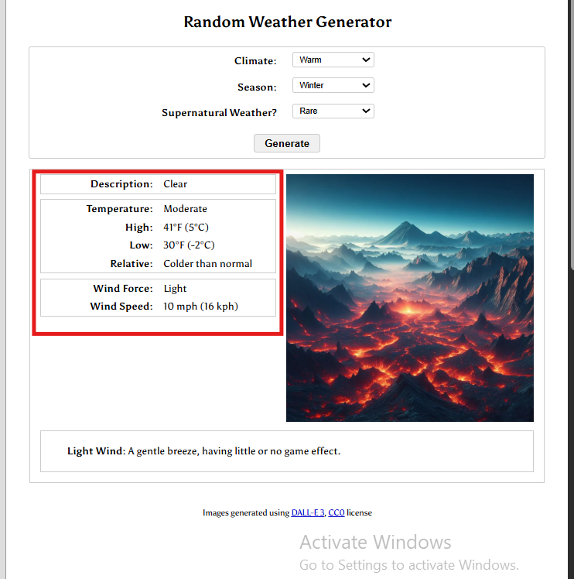 | BE01  or AE06
10 |  | Extract Weather Description Text | 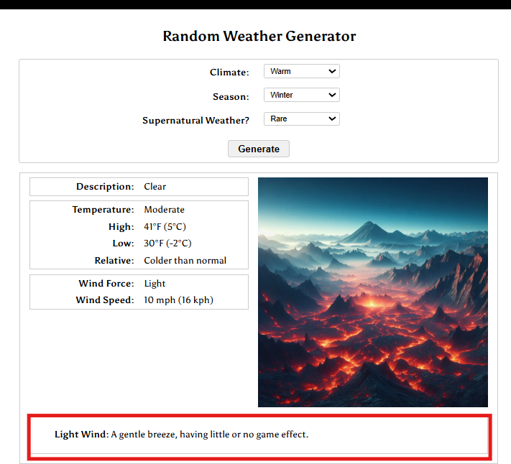 | BE01  or AE06
11 |  | Print Weather Data (info ,Description)
12 |  | Save Weather Data To output.txt file in Documents |  | AE05  or  AE07 | 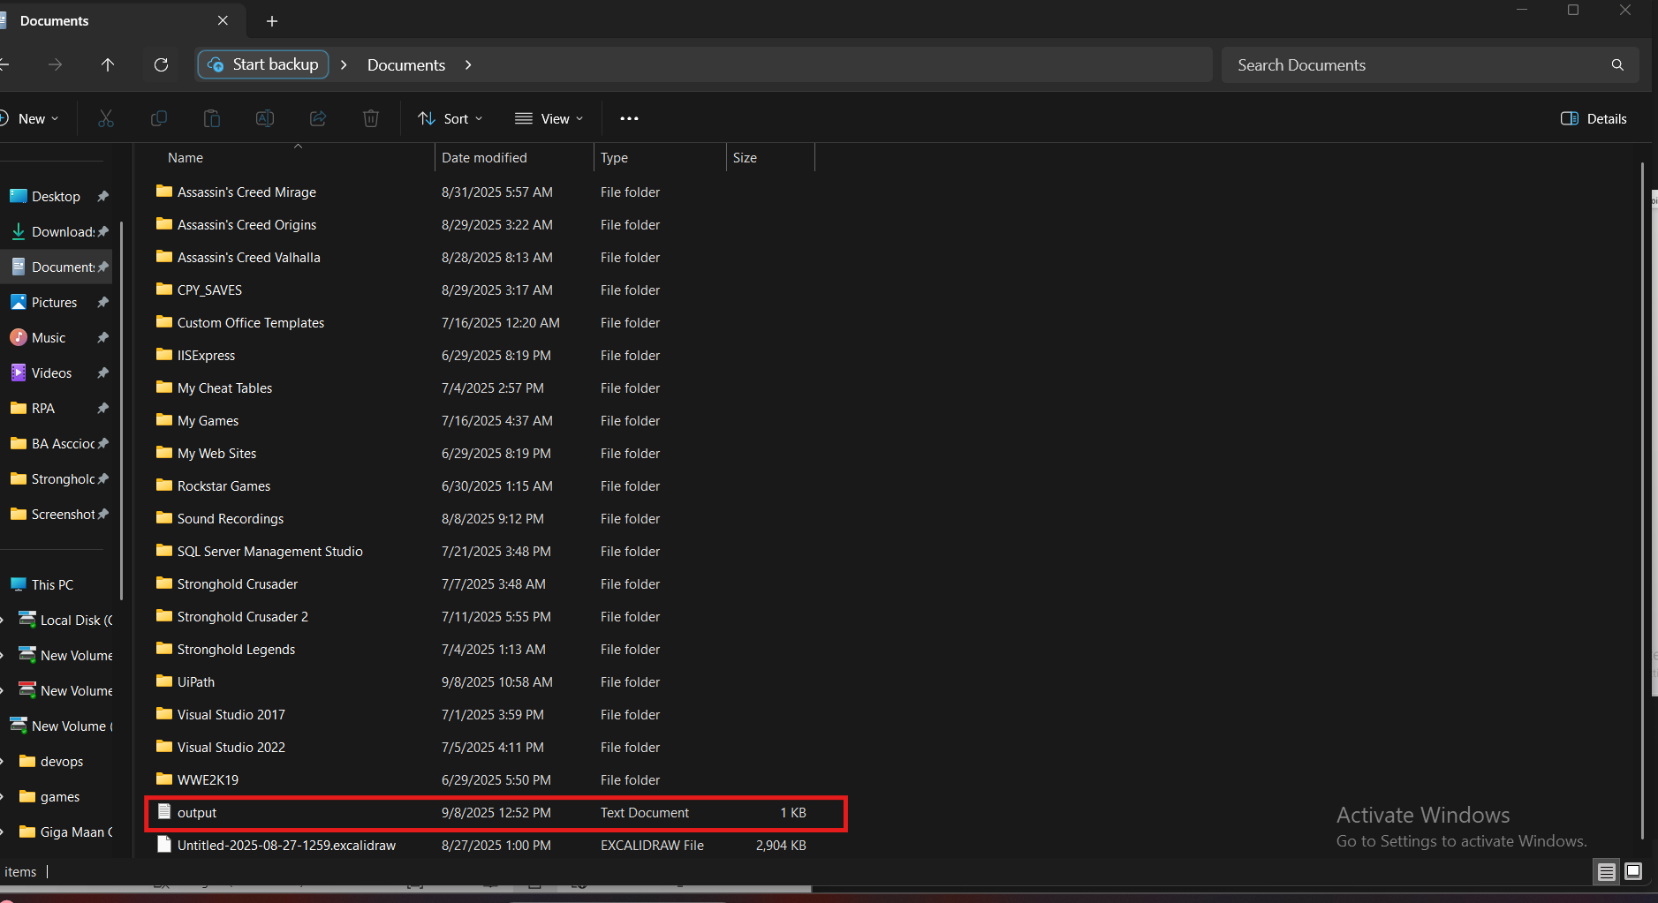

To-be process description

Input/Output data description

The following table should contain details regarding the inputs that every action of the process takes.

# | Sample | Type | Input/Output | Process step # | Storage location
1 | Weather Description | credentials(string) | output | 9 | memory
 | Weather info |  |  | 10

Exceptions Handling
The Business Process Owner and Business Analysts are expected to document below all the business exceptions identified in the automation process. Exceptions are of 2 types, and both need to be addressed:
- Known exceptions - previously encountered. A scenario is defined with clear actions and workarounds for each case.
- Unknown exceptions - New situation that was not encountered before. It cannot be predicted and in case it happens it needs to be flagged and communicated to an authorized person for evaluation.

Known business exceptions

# | Exception description | Action to be taken
BE01 | Generated weather data is missing description or numeric values | Discard output, retry generation up to 3 times; if still missing, log error and notify notify Analytical office
BE02 | Input does not match any item in dropdown list | Retry open Drop Down list 3 times , if still doesn’t match ,log error  And notify Analytical office
BE03 | Donjon page doesn’t appear in search result as first time | Retry to Click Search icon 3 times , if still doesn’t match ,log error  And notify Analytical office, IT

Unknown business exceptions
for all other cases which do not follow the rules defined an e-mail should be sent to: rpa_support@raya.it.com with a screen shot and robot should proceed to next transaction .

Applications errors and exceptions handling

Known applications errors and exceptions

# | Exception description | Action to be taken
AE01 | Web browser fails to open the weather generator website | Retry opening up to 3 times; if still failing, log error and notify IT/ Analytical office
AE02 | Weather generator page does not load or times out | Refresh page, retry up to 3 times; if still failing, log issue and escalate to IT
AE03 | Dropdown menus (climate, season, condition) fail to populate or become unresponsive | Refresh page, retry; if issue persists, log as UI failure and escalate to IT
AE04 | Weather generation button click fails or does not return output | Retry action 3 times; if no result, log exception and notify Analytical office
AE05 | Generated output file cannot be saved to the storage location | Retry saving up to 3 times; if unsuccessful, log issue and escalate to Analytical office for manual resolution
AE06 | Weather generator returns unsupported or corrupted data format | Reject output, log issue, notify Analytical office team for investigation
AE07 | File saving process interrupted due to application crash or freeze | Restart application, attempt to save again; if persistent, escalate to IT

Unknown applications errors and exceptions
.robot should attempt to access the application 3 times then it should terminate process and escalate to Project Manager and Director of Accounting and IT Team.

Reporting
In this section all the reporting requirements of the business should be detailed so that when the automation solution is moved to production the administrators can track the performance of the solution.

Report Type | Update frequency | Details | Monitoring Tool to visualize the data
Error & Exception Report | Real-time / Daily | Captures invalid inputs, generator downtime, or failed file saving attempts | Orchestrator Dashboard / Error Log File
Txt file | After each run | Weather Data are stored | Orchestrator Dashboard / Bot Logs

In scope for automation
All process Steps are in scope of Automation.

Out of scope for automation
All process Steps are in scope of Automation .

Change/Improvement details
Use this section to detail the list the change or improvement opportunity in the To-Be Process.
Important aspects to be mentioned: what is the initiative, expected outcome, expected completion date, contact person for details, and if will impact the current automation request.

# | Initiative Name | Process Action(s) where it is identified | Impact on current Automation Request | Expected Completion Date | Contact Person

Other

Additional sources of process documentation
Item | Location
Video Recording of the process (Optional)
Business Rules Library (Optional)
Other documentation (Optional)
Standard Operating Procedure(s) (Optional)
High Level Process Map (Optional)
Detailed level process map (Optional)
Work Instructions (Optional)
Input Files (Optional)
Output Files (Optional)

Change requests
# | Date | Change description | Affected process steps / section | Change reason | Change initiator

Document approval

